Entity Relationship Diagram

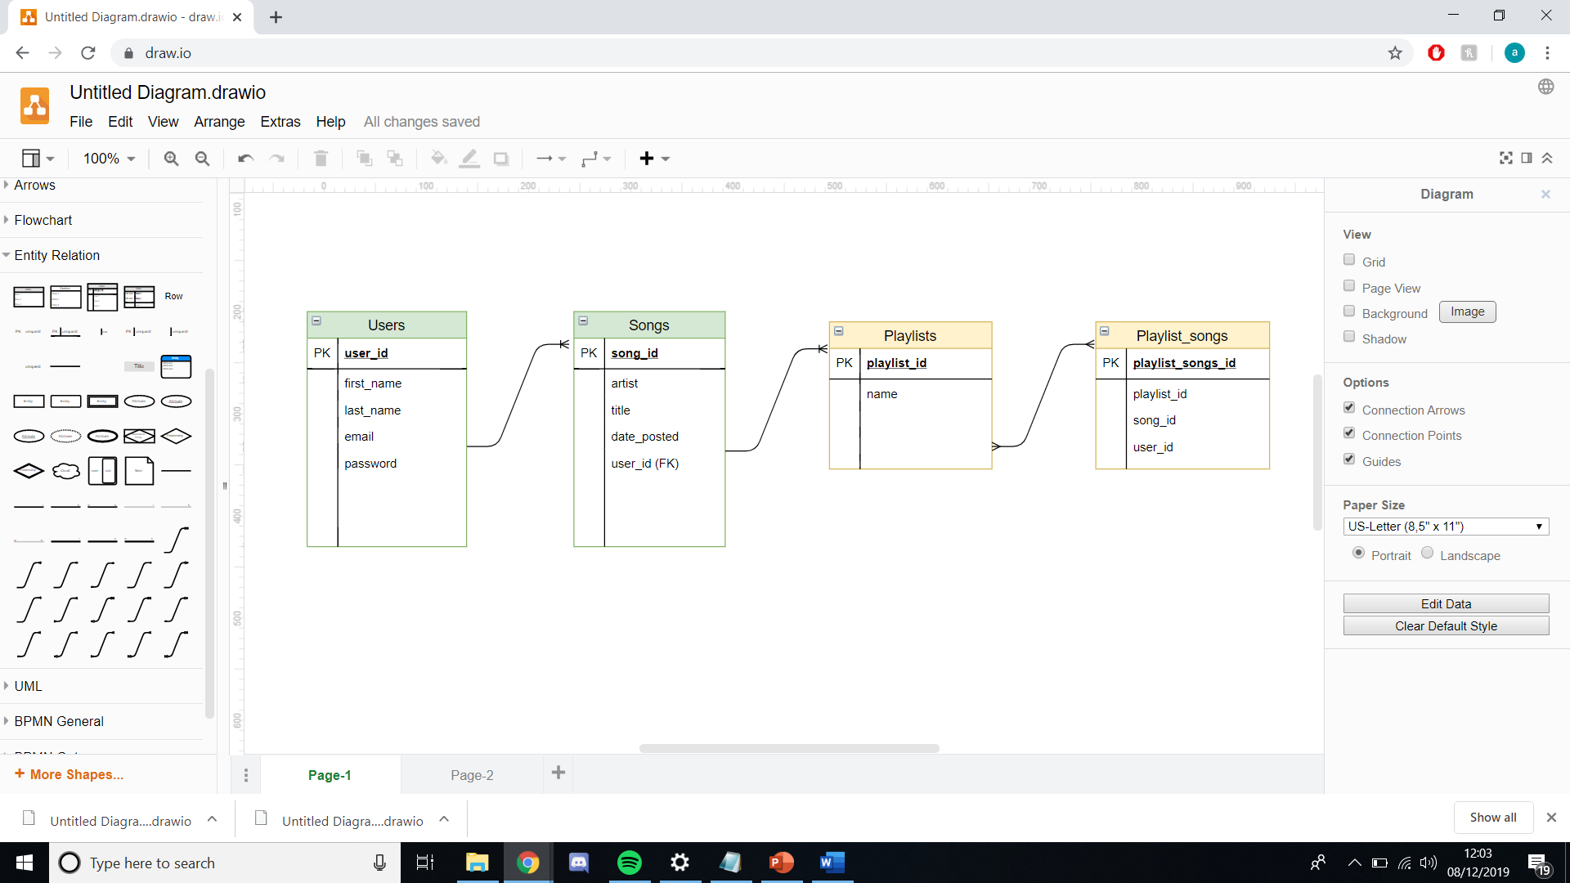

This is the ERD showing the tables that were used for this project. The two tables that were used were the Users and Songs tables with a 1 to many relationship.

The other two tables which solved the many to many relationships which would have occured between the playlist and songs tables were not implemented as the minimum viable product was reached with the must have tables.